INEQUALITIES
Pearson Edexcel – Monday 8 June 2020 - Paper 3 (Calculator) Higher Tier
1.
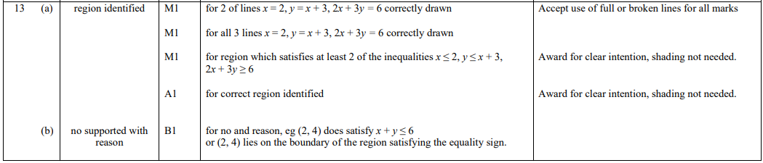
Pearson Edexcel - Thursday 6 June 2019 - Paper 2 (Calculator) Higher Tier
2.
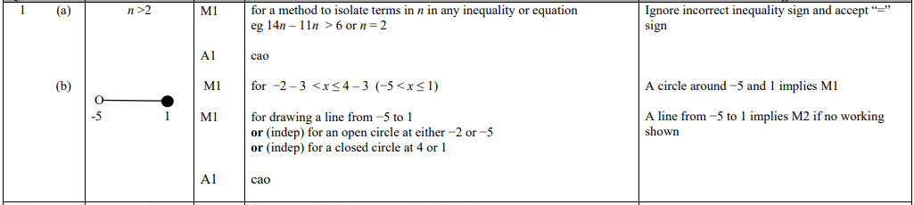
Pearson Edexcel - Thursday 8 November 2018 - Paper 2 (Calculator) Higher Tier
3.
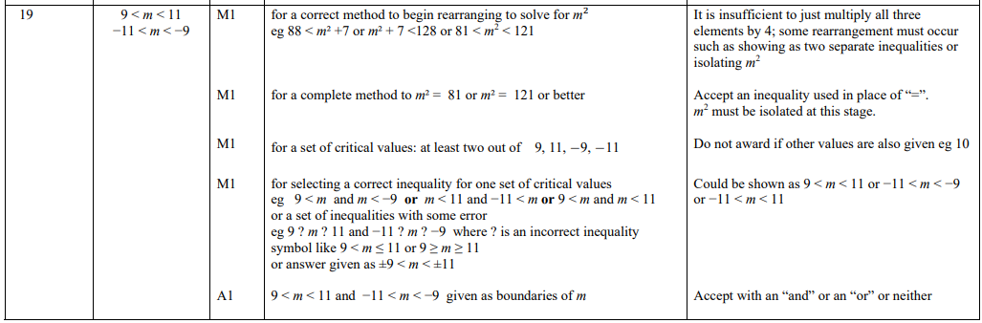
Pearson Edexcel - Thursday 24 May 2018 - Paper 1 (Non-Calculator) Higher Tier
4.
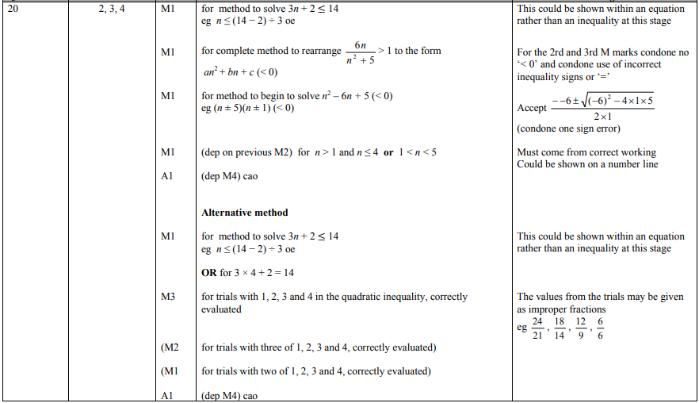
Pearson Edexcel - Tuesday 13 June 2017 - Paper 3 (Calculator) Higher Tier
5.
Pearson Edexcel - Tuesday 13 June 2017 - Paper 3 (Calculator) Higher Tier
6.
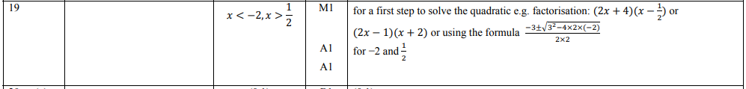
Pearson Edexcel - Specimen Papers Set 2 - Paper 1 (Non-Calculator) Higher Tier
7.
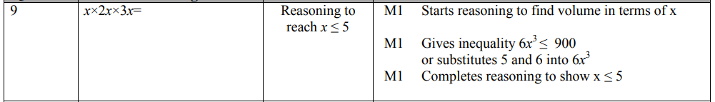
Pearson Edexcel - Specimen Papers Set 2 - Paper 1 (Non-Calculator) Higher Tier
8.
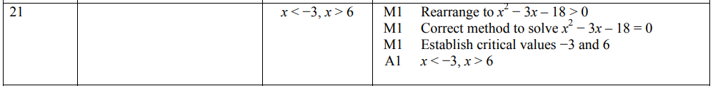
Pearson Edexcel - Specimen Papers Set 1 - Paper 3 (Calculator) Higher Tier
9.
Pearson Edexcel - Sample Paper 1 - (Non-Calculator) Higher Tier
10.
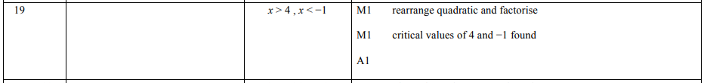
Pearson Edexcel - Sample Paper 3 - (Calculator) Higher Tier
11.
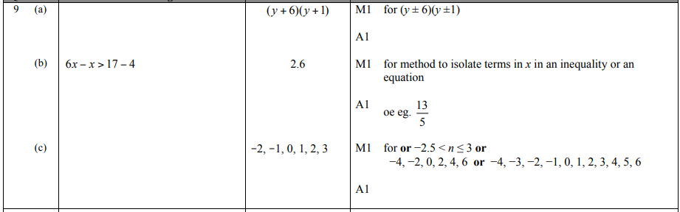
Pearson Edexcel - Thursday 4 June 2015 - Paper 1 (Non-Calculator) Higher Tier
12.
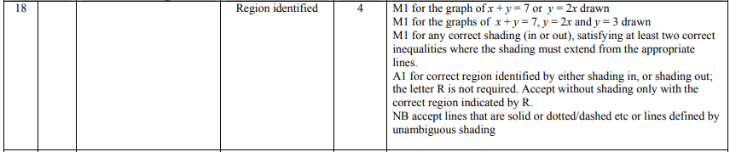

Pearson Edexcel - Wednesday 5 November 2014 - Paper 1 (Non-Calculator) Higher Tier
13.
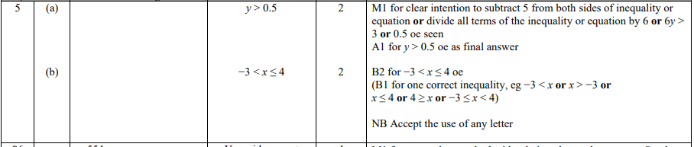
Pearson Edexcel - Friday 13 June 2014 - Paper 2 (Calculator) Higher Tier
14.
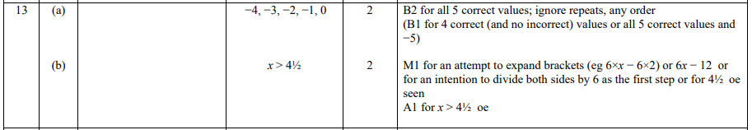
Pearson Edexcel - Tuesday 11 June 2013 - Paper 1 (Non-Calculator) Higher Tier
15.
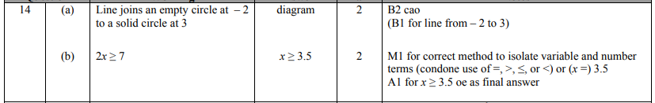
Pearson Edexcel - Monday 4 March 2013 - Paper 2 (Calculator) Higher Tier
16.
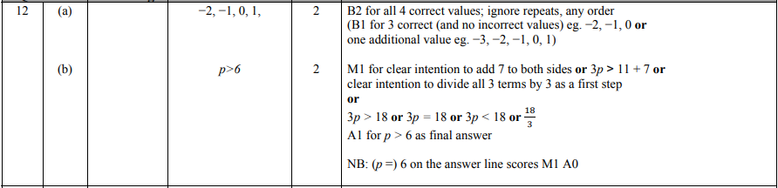
Pearson Edexcel - Thursday 8 November 2012 - Paper 2 (Calculator) Higher Tier
17.
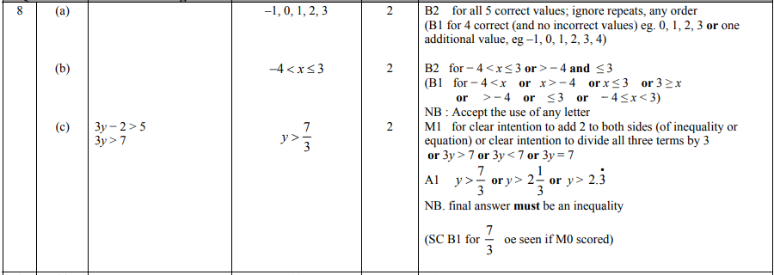
Pearson Edexcel - Wednesday 13 June 2012 - Paper 2 (Calculator) Higher Tier
18.
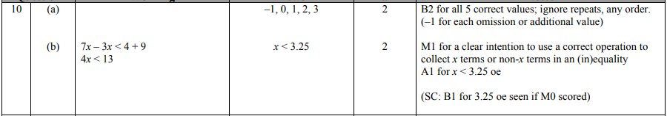
Pearson Edexcel - Monday 5 March 2012 - Paper 4 (Calculator) Higher Tier
19.
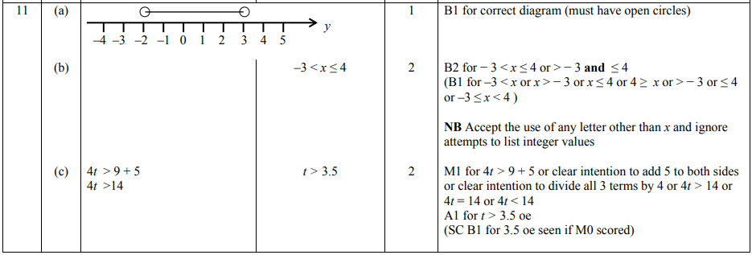
Pearson Edexcel - Monday 14 November 2011 - Paper 4 (Calculator) Higher Tier
20.
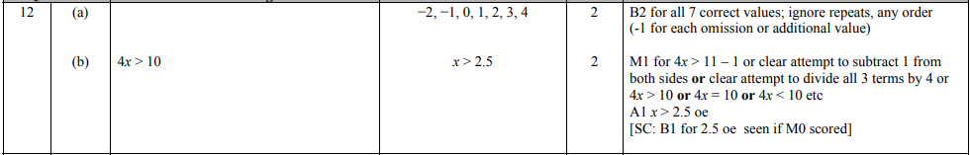
Pearson Edexcel - Friday 10 June 2011 - Paper 4 (Calculator) Higher Tier
21.
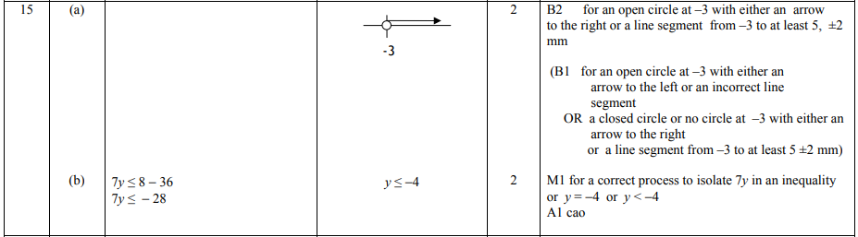
Pearson Edexcel - Friday 12 November 2010 - Paper 4 (Calculator) Higher Tier
22.
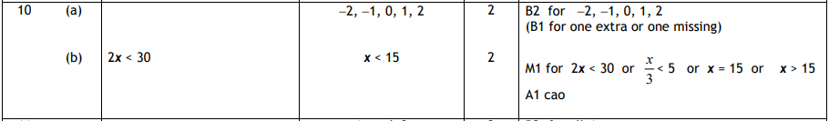
Pearson Edexcel - Friday 11 June 2010 - Paper 4 (Calculator) Higher Tier
23.
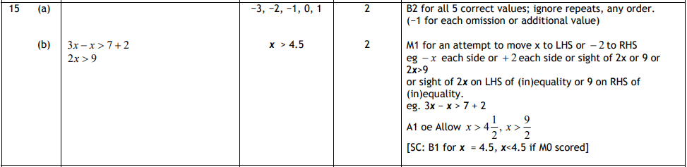
Pearson Edexcel - Thursday 5 November 2009 - Paper 3 (Non-Calculator) Higher Tier
24.
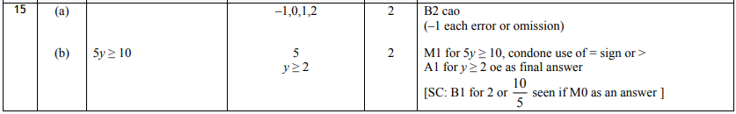

OCR GSCE – Monday 9 November 2020 – Paper 6 (Calculator) Higher Tier
25.
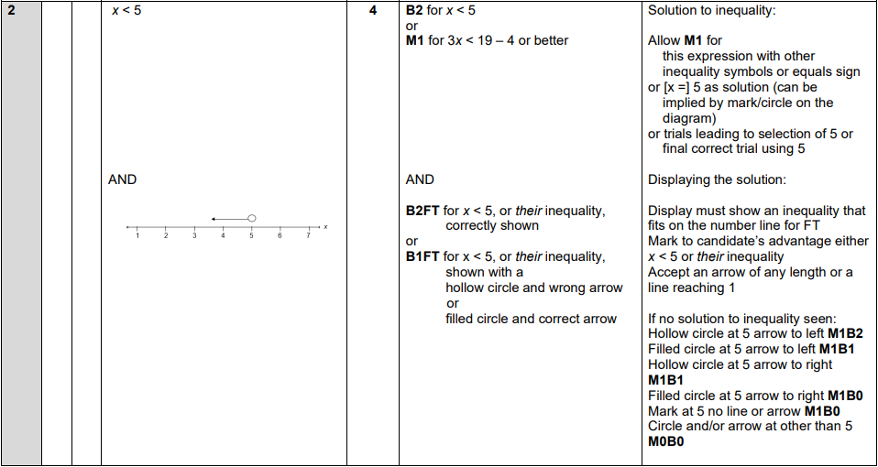
OCR GSCE – Monday 11 November 2019 – Paper 6 (Calculator) Higher Tier
26.
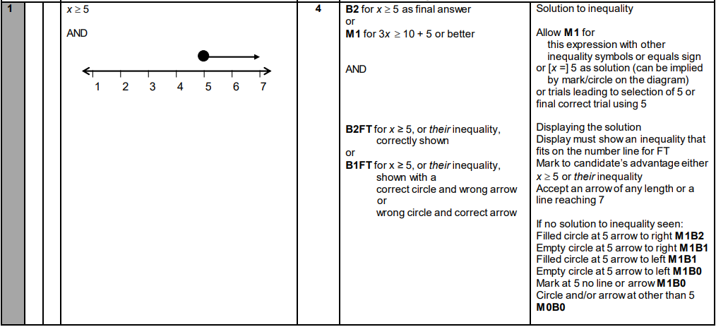

OCR GSCE – Tuesday 11 June 2019 – Paper 6 (Calculator) Higher Tier
27.
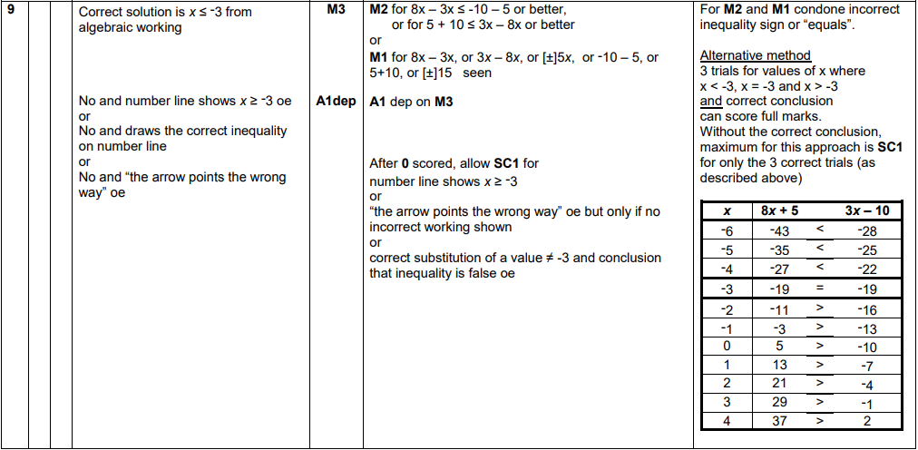
OCR GSCE – Thursday 7 June 2018 – Paper 5 (Non - Calculator) Higher Tier
28.
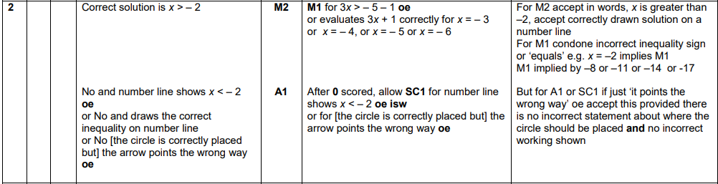
OCR GSCE – Tuesday 6 November 2017 – Paper 5 (Non - Calculator) Higher Tier
29.
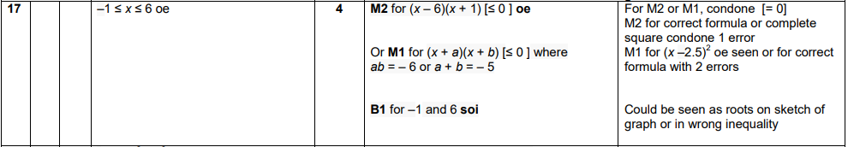

OCR GSCE – Thursday 8 June 2017 – Paper 5 (Non - Calculator) Higher Tier
30.
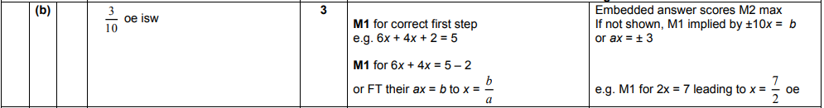
OCR GSCE – Sample Papers – Paper 5 (Non - Calculator) Higher Tier
31.
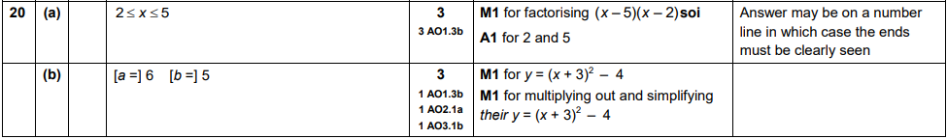
AQA GSCE – Thursday 8 June 2020 – Paper 3 (Calculator) Higher Tier
32.
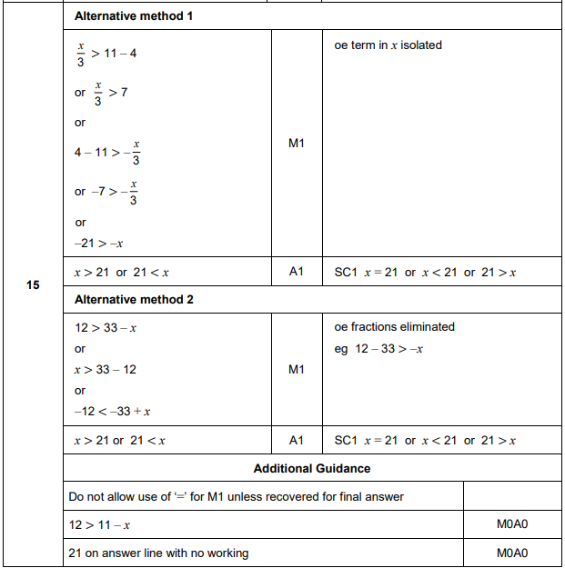

AQA GSCE – Thursday 6 June 2019 – Paper 2 (Calculator) Higher Tier
33.
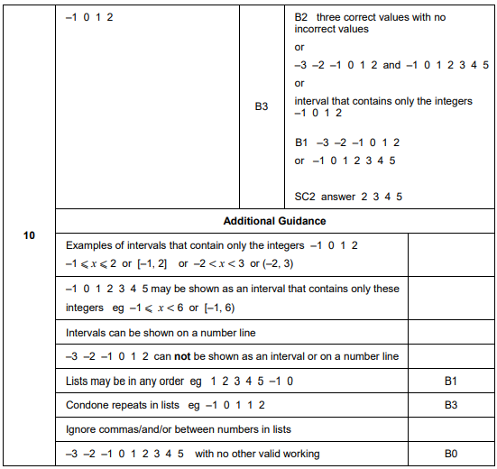
AQA GSCE – Monday 12 November 2018 – Paper 3 (Calculator) Higher Tier
34.
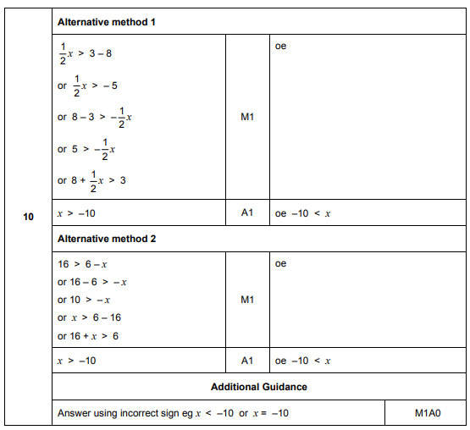
AQA GSCE – Monday 24 May 2018 – Paper 1 (Non - Calculator) Higher Tier
35.
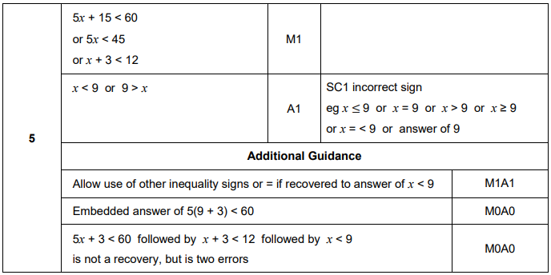
AQA GSCE – Tuesday 12 June 2018 – Paper 3 (Calculator) Higher Tier
36.
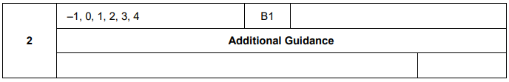
AQA GSCE – Thursday 2 November 2017 – Paper 1 (Non - Calculator) Higher Tier
37.
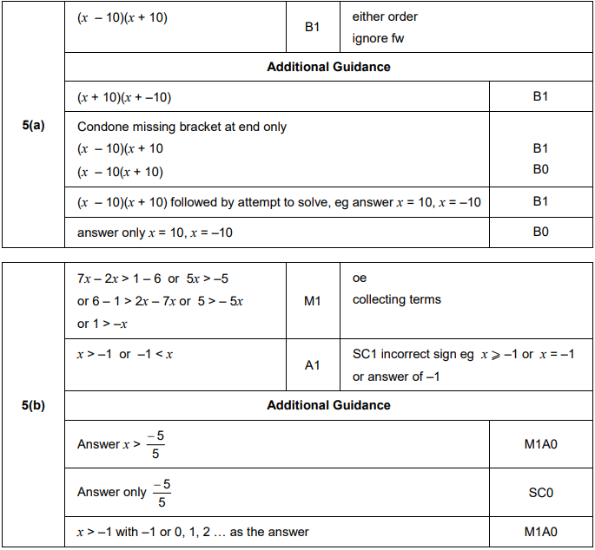
AQA GSCE – Wednesday 8 November 2017 – Paper 3 (Calculator) Higher Tier
38.
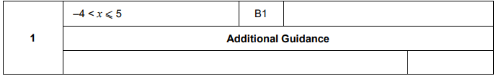

AQA GSCE – Wednesday 25 May 2017 – Paper 1 (Non - Calculator) Higher Tier
39.
AQA GSCE – Tuesday 13 June 2017 – Paper 3 (Calculator) Higher Tier
40.
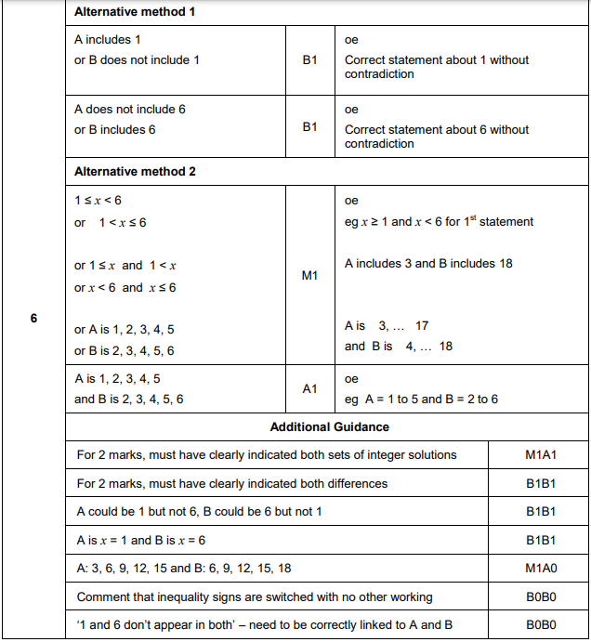
AQA GSCE – Sample Paper 1 (Non - Calculator) Higher Tier
41.
